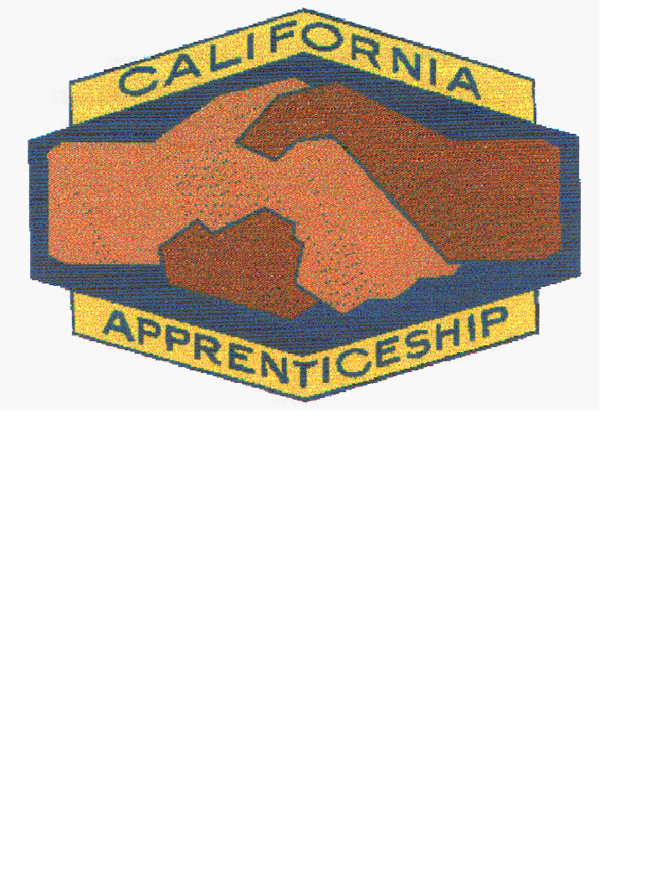
August 1st 2020

Dear Apprenticeship Program,

We are busy planning the 60th Anniversary of the California Conference on Apprenticeship. The 31st biennial conference is to be held May 3rd, 2022 – May 6th, 2022.

The biennial conference is comprised of all members of the apprenticeship community in the State of California. Attendees will include the California Apprenticeship Council, State Division of Apprenticeship Standards, committee members and training directors of all occupations, school administrators, high school and community college instructors as well as the general public. This will be another great opportunity to develop apprenticeship ideas and network with others interested in apprenticeship.

The event will take place in Monterey, California, at the Hilton Garden Inn Monterey. Pre-conference will start on Tuesday, May 3rd, 2022, with networking events, exhibitor set up and registration. Conference sessions will begin Wednesday morning, May 4th, 2022, with an opening session, and continue through Thursday, May 5th, 2022. An apprenticeship banquet will be held on Thursday evening. An abbreviated CAC meeting will follow on Friday, May 6th, 2022 at the completion of the conference.

Historically, each Apprenticeship Committee or Sponsor has supported the Conference at a fee of $1.00 per apprentice to help defray the costs and to assure a successful conference.

Conference fees should be made payable to California Conference on Apprenticeship. Please complete and return the lower portion of this letter with your payment by
March 31st, 2022.

Thank you for your support.

Sincerely,
Alex Beltran
Alex Beltran
Chairman, California Conference on Apprenticeship

PER CAPITA PAYMENT (Please submit by March 31st, 2022)

Program Name: _____________________________________________

DAS File #(s): ______________________________________________

Address: ___________________________________________________

______ # Apprentices X $1.00 = Total Enclosed: $ ________

Mail to: C/O Alex Beltran
California Conference on Apprenticeship
2020 Williams St. Suite A, San Leandro, CA 94577

OFFICERS

Alex Beltran, Chairman
Painters and Allied Trades
District Council 16 JATTF

Luis Reyes, Co-Chairman
S. CA JJATT HVAC&R Training

Charles Henkels, Secretary
Career & Technical Education
Norco College

Dr. Gracie Young, Co-Secretary
Greater East Bay Barbering &
Cosmetology Apprenticeship

Jeffery Christophersen, Treasurer
Painters and Allied Trades
District Council 16 JATTF

Veronica Godinez, Co-Treasurer
N. CA Cement Masons JATC

COMMISSIONERS

Scott Gordon

Jim Hussey

Derrick Kualapai

Louis Ontiveros

LIAISON

Deneen Phillips
DAS Staff

